**SALESFORCE TO ChatGPT INTEGRATION**

Create Account on OpenAi and search documents

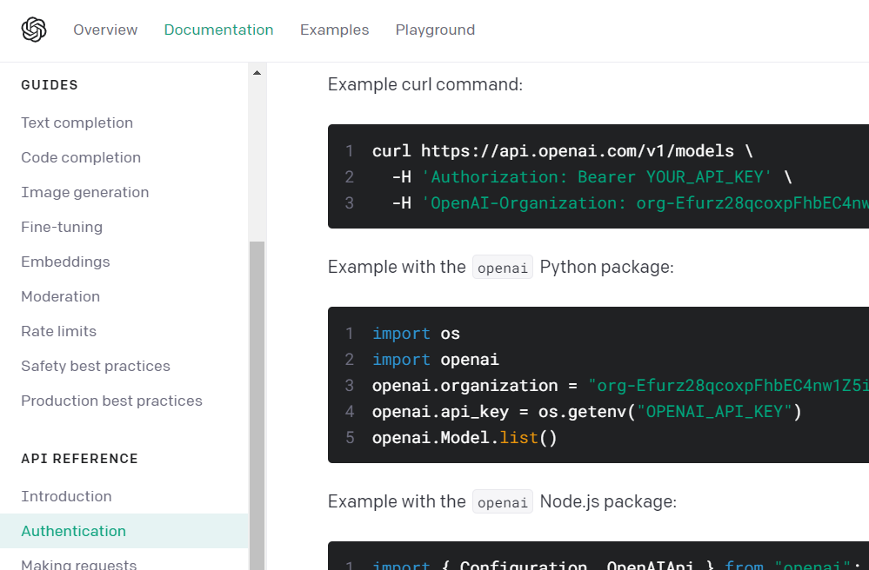

**Copy this Api key**

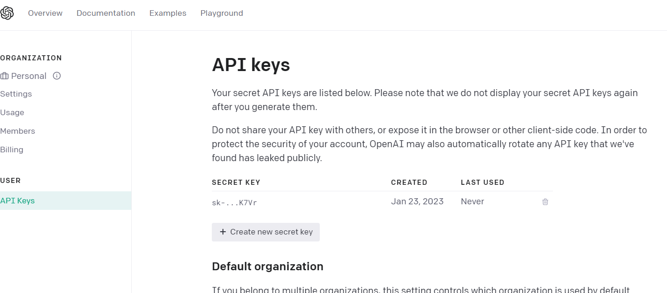

Create Remote site setting in your salesforce org

